

SEWARD PARK

PLANTING Project Narrative

The following project include work to carry out for Phase 2 planting, Phase 3 establishment and associated activities. Please find a summary below and site-specific information about previous and current phases of activities.

**Site Description and Context:**

* *Census Tract:* 102; *1999-2000 Tree-iage Value:* 2; *Aspect:* East; *Percentage of zone with a slope greater than 40%: 9*% of zone; *66%+ slope*: No; *Percentage of zone designated as wetland:* 0% of zone; *Slope Position:* Mid; *Canopy:* Closed; *Other:* ECA Steep Slope, ECA Wildlife Corridor; adjacent official trails; social use/paths

**Work History/Relevant Information:**

* This area is the location of [sword fern decline](https://www.greenseattle.org/information-for/forest-steward-resources/restoration-resources/gsp-research/sword-fern-decline-at-seward-park/) in Seward Park. [Sword fern experimental planting](https://sewardparkswordferndieoff.blogspot.com/2018/03/experimental-planting-at-seward-park.html) was carried out in 2018 in the northern extent of MF4 and southern extent of MF7. In 2019, crews installed 400 plants along the Hatchery Trail in northern extent of MF4. This planting shall avoid these experimental plantings.
* Social path forming through MF4 that connects “sword fern decline” area near large root wad and the upper loop road of the park at junction of road/zones MF4 and FES3. Objective is to plant on top of path to close it.
* Cistern for watering-in plants is located at Sqebeqsed/Hatchery Trail junction, SW corner of MF7 & NW corner of MF4.

**Pre-Project Meeting for Contractor Awarded Project:** Contractor shall attend a Pre-Work Site Visit before beginning Work. The Project Manager will notify Contractor of the time and place of the Pre-Work Site Visit in order to review Scope of Work, logistics and the Work Schedule.

**Work Summary**

|  |  |  |  |  |
| --- | --- | --- | --- | --- |
| Project Zone | Acres | Plants | Activity | Work Schedule |
| Portion of MF4 & MF7 | 5.97 | 2660 | Installation of plants, amendment additions, water-in plants, stormwater and erosion control, litter removal | 10/19/20-2/27/20 |
| TOTAL | **5.97** | **2660** | **Trees 840; Shrubs 1400; Forbs & Ferns 420** |  |

**Work Details:** Work outlined in the Work Summary should follow the specifications outlined in the Green Seattle Partnership Crew Work Specifications, available online here: <https://www.greenseattle.org/wp-content/uploads/2020/04/GSP-Work-Specification-Update_April-2020.pdf>. Site-specific considerations are included below.

* Contractor shall perform target weed removal, stormwater and erosion controls, compost pile weed construction (where appropriate), and litter removal throughout all zones listed in Work Summary. At Contractor’s discretion, use one or more combination of methods outlined in the GSP work specifications to meet performance criteria by the end of the Work Schedule.
  + Brushing: Scarify 2’ around each regenerating native tree by cutting back any overhanging tree and shrub vegetation (both native and invasive) sufficient to create a 45-degree cone of light to seedling.
* There are several pocket wet areas throughout the site that are not listed as designated wetlands.

**Plant Stock Type:** All conifer seedling stock will be a minimum of P-1 (min. 12” height) and from a seed source suited to the site unless otherwise noted in the Plant List. Hardwood tree and shrub stock should be a minimum of 2-3’ tall displaying multiple branching. Some specific material plant type noted in the plant lists.

**Plant Staging and Seeding:** Staging is the distribution of plants across a site in preparation for planting. Plant palettes are selected to meet general site conditions, however within each site there is variability in soils, sunlight and moisture availability. The following considerations should be made for microsites:

* Tables with Plant and Stock Type, *Average* Desired Plant Density, Spacing *Average* (on center) provided below with plant lists:
  + Do not plant seedlings closer than 10’ to another existing tree unless noted in the Plant Density table.*
  + Shrub, Forbs and Ferns and Gramonids may be staged/planted as close as 3 feet on center if noted for installation in groups
* Flag each tree seedling and shrub

*For shade tolerant conifers (STC), plant in an appropriate microsite that includes slash, coarse woody debris or dead brush within two feet of the planted seedling. STC are not subject to the desired spacing and can be planted within four feet of another STC and within desired spacing outlined in the Specifications. STC shall be planted in microsites where available, otherwise they shall be planted evenly across the planting area.

*Do not plant *Arbutus menziesii* and *Quercus garryana* within 20 feet of any other tree

**Plant Installation Detail:** The following planting directions apply to all planting stock unless otherwise noted:

* Scarify 2’ around planting site and cut back any overhanging understory vegetation sufficient to create a 45-degree cone of light to seedling.
* For container plants: apply [Plant Success Tablets](http://www.plant-success.com/product/plant-success-tablets/) to root zone of each tree and shrub per manufacturer’s instructions
* For bareroot plants: apply [Mycogrow Soluble](http://www.fungi.com/product-detail/product/mycogrow-soluble-1-lb.html) as a root dip
* All trees and shrubs shall be flagged with the 2019/20 color of [blue biodegradable tape](http://cspforestry.com/products/presco-biodegradable-roll-flagging-tape.html) on a side branch, NOT the main stem of the plant to avoid girdling damage.Additionally, all plant material from seed zones other than Puget Lowland shall also be flagged with the following:
  + **Cowlitz/Toutle/Lower Columbia:** orange vinyl tape
  + **Oregon Willamette Valley:** yellow vinyl tape
  + **Oregon Coast:** green vinyl tape
  + **Northern California:** white vinyl tape

**Stormwater and erosion controls** throughout all zones listed in Work Summary.Temporary erosion and sediment controls (TESC) shall be constructed in conjunction with all clearing activities where appropriate in Environmentally Critical Areas or any area with the potential for erosion. Construction Stormwater Pollution Prevention Plan (CSPPP) for this GSP project follows. Implement and maintain an updated CSPPP, beginning with initial land disturbance. Retain the Project CSPPP on site or within reasonable access to the site. Plant Ecologist may modify the plan as needed.

Table 1 Stormwater and Erosion Control Plan for Seward Park Planting 2020-2021

| **#** | **Element Name** | **√** | **Best Management Practice** | **Notes** |
| --- | --- | --- | --- | --- |
| 4.1 | Protect Waterways | **√** | E1.15 Mulching, Matting, and Compost Blankets | Applies in disturbed areas that require immediate erosion protection: exposed soils (less than 50% native vegetation cover) left for 2 – 30 working days |
| **√** | E3.35 Straw Wattles, Compost Socks, and Compost Berms | Applies in disturbed areas that require immediate erosion protection: steep, exposed soils during short project delays; on exposed soils requiring stabilization until permanent vegetation can be established; as an alternative to silt fence for perimeter control. |
|  | E3.30 Vegetated Strip |  |
| 4.2 | Prevent erosion and sediment transport from the site | **√** | E1.35 Preserve Natural Vegetation | Minimize impacts to native vegetation by carrying out Project Activities only where target weeds are present. |
|  | E1.35 Buffer Zones |  |
|  | E3.10 Filter Fence |  |
| **√** | Ecology BMP C231 Brush Barrier | Create weed compost piles per the Work Specifications. “Windrows” on steep slopes may be used as brush barrier. |
|  | E3.30 Vegetated Strip |  |
| **√** | E3.35 Straw Wattles, Compost Socks, and Compost Berms (includes Coir logs) | Applies in disturbed areas that require immediate erosion protection: steep, exposed soils during short project delays; on exposed soils requiring stabilization until permanent vegetation can be established; as an alternative to silt fence for perimeter control. |
| 4.3 | Prevent erosion and sediment transport from the site by vehicles |  | E3.65 Cleaning Inlets and Catch Basins |  |
| **√** | E3.70 Street Sweeping and Vacuuming | Sweep and remove any organic material that falls on impervious surface |
| 4.4 | Stabilize soils |  | E1.10 Temporary Seeding |  |
| **√** | E1.15 Mulching, Matting, and Compost Blankets | Applies in disturbed areas that require immediate erosion protection: exposed soils (less than 50% native vegetation cover) left for 2 – 30 working days |
| **√** | E1.20 Clear Plastic Covering | Applies in disturbed areas that require immediate erosion protection: exposed soils (less than 50% native vegetation cover) left for 2 – 30 working days |
| **√** | E1.40 Permanent Seeding and Planting | *See Work Details regarding seeding and planting native plants* |
| **√** | E2.45 Dust Control | Prevent surface and air movement of dust from exposed soil surfaces onto roadways, adjoining properties and into drainage channels and receiving waters |
|  | Ecology BMP C130 Surface Roughening |  |
| **√** | Protect Wetland Soils | Work in wetlands or wet areas avoided when inundated (flooded) or when soils are saturated up to the surface. Saturated soils will glisten. Compost piles located outside of wetland/saturated soils or disposed of off-site. *See Work Specifications 1.2 Project Phasing.* |
| 4.5 | Protect Slopes |  | Level Spreader |  |
|  | E2.35 Check Dams |  |
|  | E2.80 Earth Dike and Drainage Swale |  |
|  | Ecology BMP C201 Grass-lined Channels |  |
|  | Ecology BMP C130 Surface Roughening |  |
|  | Modified Straw Wattles and Fascines |  |
| 4.6 | Protect storm drains | **√** | E3.25 Storm Drain Inlet Protection | E3.25 applies where downslope storm drain inlets are operational prior to the Work Schedule. Within the Project Zone, protection should be provided for all storm drain inlets downslope of Project Activities AND adjacent areas where there is potential for sediment transport into bodies of water and drainage systems. |
|  | E3.65 Cleaning Inlets and Catch Basins |  |
| **√** | E3.70 Street Sweeping and Vacuuming | Sweep and remove any organic material that falls on impervious surface |
| 4.7 | Control Pollutants | **√** | C1.15 Material Delivery, Storage, and Containment | Waste materials and debris handled and disposed of to prevent contamination of stormwater. Address contaminated surfaces immediately. Spills reported immediately to Plant Ecologist. |
| **√** | C1.45 Solid Waste Handling and Disposal | In wet areas, establish work center (i.e. tool and material storage, plant delivery and primary staging location, and lunch location) outside of the wet area where soils are more stable. |
| 4.8 | Maintain Erosion and Sediment Control BMPs | **√** |  | Maintain and repair, protect and restore all temporary erosion and sediment control BMPs as needed to assure continued performance of their intended function during the Work Schedule. |

Table 1 Plant List for Seward Park MF7

|  |  |  |  |  |  |
| --- | --- | --- | --- | --- | --- |
| Botanic name | Common Name | Type | Seed Zone | Quantity | Notes |
| Abies grandis | grand fir | **Trees** | OR - 262 | **150** | STC; Install in and around downed woody debris |
| Acer circinatum | vine maple | **Shrubs** | Puget Lowlands | **300** | **I**nstall in microsites with filtered light |
| Achlys triphylla | vanillaleaf | **Forbs and Ferns** | Puget Lowlands | **30** | Install in groups of 10 near Sqebeqsed trail |
| Cornus nuttallii | Pacific dogwood | **Trees** | Puget Lowlands | **10** | Install in microsites with filtered light |
| Corylus cornuta var californica | beaked hazelnut | **Shrubs** | Puget Lowlands | **50** | **I**nstall in microsites with filtered light |
| Dryopteris expansa | spreading woodfern | **Forbs and Ferns** | Puget Lowlands | **30** | Install in groups of 10 near woody debris |
| Gaultheria shallon | salal | **Shrubs** | Puget Lowlands | **300** | Install in groups of 10 |
| Mahonia nervosa | dwarf Oregongrape | **Shrubs** | Puget Lowlands | **300** | Install in groups of 10 near mature *Mahonia* |
| Oemleria cerasiformis | Indian plum | **Shrubs** | Puget Lowlands | **100** | Install in groups of 10 |
| Polypodium glycyrrhiza | licorice fern | **Forbs and Ferns** | Puget Lowlands | **30** | Install in groups of 10 near woody debris |
| Polystichum munitum | sword fern | **Forbs and Ferns** | Puget Lowlands | **200** | Install in groups of 10 |
| Pseudotsuga menziesii var menziesii | Douglas-fir | **Trees** | OR - 8/262 | **50** | Install in full sun |
| Rhamnus purshiana | cascara | **Trees** | Puget Lowlands | **150** | **I**nstall in microsites with filtered light |
| Rubus ursinus ssp macropetalus | trailing blackberry | **Shrubs** | Puget Lowlands | **50** | Install in groups of 10 well outside trail corridors |
| Salix scouleriana | Scouler's willow | **Trees** | Puget Lowlands | **150** | Live stakes from FES3; Install in microsites with filtered light |
| Symphoricarpos albus var laevigatus | common snowberry | **Shrubs** | Puget Lowlands | **300** | Install in groups of 10 |
| Taxus brevifolia | Pacific yew | **Trees** | Puget Lowlands | **30** | STC; Install in and around downed woody debris |
| Tellima grandiflora | fringecup | **Forbs and Ferns** | Puget Lowlands | **100** | Install in groups of 10 near trails |
| Thuja plicata | western redcedar | **Trees** | OR - 1/262 | **200** | Install in and around downed woody debris |
| Trillium ovatum ssp ovatum | western trillium | **Forbs and Ferns** | Puget Lowlands | **30** | Install in groups of 10 near Sqebeqsed trail |
| Tsuga heterophylla | western hemlock | **Trees** | OR - 5/262 | **100** | STC; Install in and around downed woody debris |
|  |  |  | **TOTAL** | **2660** | **Trees 840; Shrubs 1400; Forbs & Ferns 420** |

|  |  |  |  |
| --- | --- | --- | --- |
| Plant and Stock Type | Desired Plant Density | Spacing Average  (on center) | Divide Square Footage by: |
| Trees | Sparse | 18 ft | 324 ft2 |
| Shrubs, Forbs & Ferns | Sparse | 12 ft | 144 ft2 |

**Plant Staging and Seeding**

Staging is the distribution of plants across a site in preparation for planting. Plant palettes are selected to meet general site conditions, however within each site there is variability in soils, sunlight and moisture availability. **The following considerations should be made for microsites**:

* The Clump-Gap mosaic planting pattern should be used to address microsites. The basic pattern is that 3-5 plants of each species are “clumped” with several other groups of 3-5 plants of other species. Between these clumps are gaps where individuals of the different species are randomly placed with wider spacing.
* For shade tolerant conifers (STC), plant in an appropriate microsites that includes slash, coarse woody debris or dead brush with n in two feet of the planted seedling. STC are not subject to the desired spacing and can be planted within four feet of another STC and within desired spacing outlined in the Specifications. STC shall be planted in microsites where available, otherwise they shall be planted evenly across the planting area.
* Do not plant seedlings closer than 10’ to another existing tree. *

*For shade tolerant conifers (STC), plant in an appropriate microsite that includes slash, coarse woody debris or dead brush within two feet of the planted seedling. STC are not subject to the desired spacing and can be planted within four feet of another STC and within desired spacing outlined in the Specifications. STC shall be planted in microsites where available, otherwise they shall be planted evenly across the planting area.

**Plant Installation Detail**

The following planting directions apply to all planting stock unless otherwise noted:

* For container plants: apply [Plant Success Tablets](http://www.plant-success.com/product/plant-success-tablets/) to root zone of each tree and shrub per manufacturer’s instructions
* For bareroot plants: apply [Mycogrow Soluble](http://www.fungi.com/product-detail/product/mycogrow-soluble-1-lb.html) as a root dip
* Backfill each planting hole with 1-gal of wood chips in addition to adding amendments noted above
* Apply two 5-gal buckets of wood chips to each tree and shrub
* Water in each tree with water from cistern located at Sqebeqsed trail

**Project Boundaries**

The boundaries depicted on the maps delineate the project zones. The GSP restoration zones are noted in the Work Summary and can be found by using the GSP Reference Map <http://arcg.is/1ayTq9>. Contractor is responsible for completing all Work to boundaries. The project boundaries will consist of easily identifiable features (including, but not limited to, roads, trails, streams, or changes in forest type or invasive weed cover). Flagging will be used for areas where identifiable features are absent. Contractor is responsible for understanding the location of all boundaries. Unless otherwise directed, failure to complete Work to boundaries in any Project Zone renders Work in that Project Zone incomplete. No payment will be provided for Work that extends beyond Project Zone boundaries.

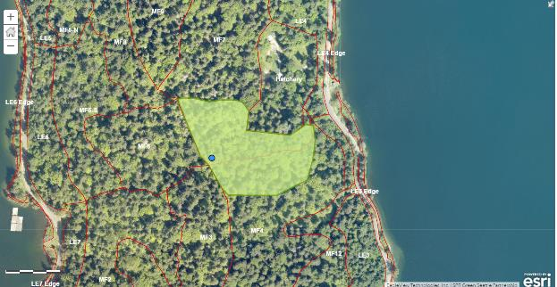

Figure 1 Planting Area for Seward Park Planting 2020-21. Blue point denotes location of cistern.

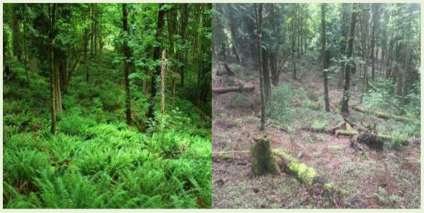

Figure 2 Photos showing before and after symptoms of "sword fern decline"

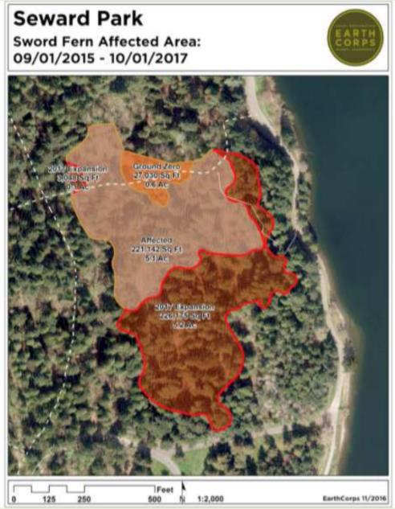

Figure 3 EarthCorps' generated map of "Ground Zero" of sword fern decline and areas of expansion

Figure 4 Image of 2019 plant installation along Hatchery Trail on northern boundary of MF4

Figure 5 Cistern located at junction of Sqebeqsed-Hatchery Trails, SW corner of MF7 & NW corner of MF4

**SITE COMPLIANCE INSPECTION AND PAYMENT**

**Field Inspections**

Seattle Parks will conduct periodic inspections. Inspections may be done concurrently with Work but will be completed no later than 5 business days after specified Work completion dates on the Sites as well as submittal of invoice, worklogs, data, pesticide records, etc. In some cases, Seattle Parks may not have the staff needed to perform compliance with the Scope of Work.

**Reporting**

* Green Seattle Partnership CEDAR Worklog:

Contractors must submit worklogs at the same time as invoices. The landing page for CEDAR is located at: <http://seattle.cedar.greencitypartnerships.org/>. Key information shall include but is not limited to the following information: Lead Agency - “Seattle Parks”; Blanket vendor contract number with the City, and: Work accomplished at each Site. There is no need to attach pesticide records to the CEDAR worklog (see below).

* Return the seedling source survey before the conclusion of the Work Schedule

**Payment Schedule**

Contractor will schedule work based on time and materials not to exceed $30,000 total for labor, materials and taxes in order to perform the activities and performance measures outlined below and in the GSP Crew Specifications.

Contractor shall provide an invoice for time and materials to Seattle Parks by the 5th of every month, providing worklogs and pesticide records for the work completed during the previous month. If a different schedule is requested by either party, it will be agreed upon during the Pre-Work Site Visit and will be set forth in the Work schedule.

|  |  |
| --- | --- |
| **CONSULTANT:** | **CONTRACT AUTHORITY** |
|  | City of Seattle / Department of Parks and Recreation |
| BY: | BY: |
|  | Charles Ng, Parks Division Strategic Advisor |
|  |  |
|  | Seattle Parks and Recreation  800 Maynard Ave S, Suite 300  Seattle, WA 98134 |
|  |  |
| DATE: | DATE: |